Question 1 is about the following Political Cartoon
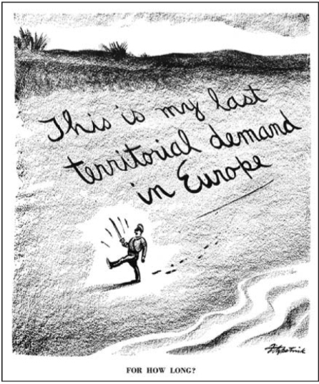
(The text on the bottom says “For How Long?”)

What is the cartoonists point of view?
- Hitler’s promises are not worth much?
- Hitler can be trusted to keep his word
- Appeasement is the way to deal with Hitler
- Keeping peace with Hitler is worth any price.

2. Which of these allowed the United States to send “all aid short of war” to Britain despite being a neutral nation in early World War II?
A. Atlantic Charter
B. Double V Campaign
C. Lend-Lease Act
D. Selective Service

3. On December 7, 1941, President Roosevelt asked Congress for a declaration of War. Which of these events led to this request?
A. Churchill’s desperate need for help in the Battle of Britain
B. German’s blitzkrieg that ended with the fall of France
C. Stalin’s agreement to sign a non-aggression pact with Hitler
D. Japan’s surprise attack on a US Naval base in Pearl
Harbor.

4. How did the federal government try to lessen public consumption of food and fuel?
A. By encouraging rationing
B. By buying war bonds
C. By controlling prices
D. By planting Victory Gardens

5. What was the main effect of Executive Order 9066?
A. The establishment of the Womens Army Auxiliary Corps.
B. The evacuation of Japanese Americans into internment camps.
C. The opening of centers for Jewish refugees in former Army Camps
D. the creation of the first African American combat unit in the Army Air Force

6. Which of these groups was targeted by white mobs in the Zoot Suit Riots?
A. African American migrants
B. Jewish American servicemen
C. Mexican American teenagers
D. German American enemy aliens

7. How did President Roosevelt respond to A Philip Randolphs threat to organize a protest march by African Americans on Washington in 1941?
A. He desegregated the military
B. He urged banning racism in the workplace
C. He ordered to National Guard to disperse the marchers
D. He signed an executive order outlawing discrimination by defense contractors.

8. The Double V Campaign south to fight against fascism and…
A. end racism in the United States
B. create a new League of Nations
C. promote communism
D. Go back to neutrality

9. On June 6, 1944, Allied forces stormed the Beaches of Normany, France. What was this event called?
A. D-Day
B. V-E Day
C. Battle of the Bulge
D. Battle of the Atlantic

10. Which of the following military oporations did the Allies choose in the Pacific War against Japan?
A. launch a massive invasion on Japan
B. Simply contain Japanese expansion
C. follow a leapfrogging campaign to secure bases on individual islands
11. How did the US End the war in Japan?
A. hiring spies for the war
B. creating colonies in Japan
C. improving aircraft technology
D. developing the atomic bomb

12. Which of these statements BEST describes how the Allies dealt with Japan afted WWII
A. The Japanese Islands were divided among the Allies to rule in segments
B. The Japanese helped restore the emperor to power
C. The Japanese were forced to make reparation payments
D. The Allies helped Japan rebuild its economy and establish a democratic government

13. Which of the following helped over 2 million U.S veterans attend college after WWII?
A. World Bank
B. GI Bill of Rights
C. Manhattan Project
D. War Production Board

14. Which of these statements BEST describes the situation after World War II of many women who had worked in war-related industries?
A. They shifted to lower-paying service jobs
B. They were eager to quit
C. They refused to give up their jobs for returning veterans
D. They competed successfully with men for jobs in heavy industry.

15. Mr. Bartlett hiked to a place called the Murphy Ranch that had some historical significance to World War II. What is it?
A. It was a storage ground for US planes going to fight in the Pacific.
B. It was a compound for German sympathizers who wanted to live in secret until the Germans won the War
C. It was a place that raised beef for the soldiers during WWII
D. This question is stupid, why are you asking it? Oh wait I think its extra credit.

Part B: Short Answers
Question 1 is about the following political cartoon.

(The text on the bottom says “For How Long?”)

1. What would someone in Europe who favored appeasement say in response to this cartoon? Give 1 example from history that you think would make the appeaser come to this conclusion? (2 pts)

2a-b. The following is the judgement of the case Korematsu v. United States, which stated that the US had the right to send the Japanese to internment camps?

.”.Compulsory (mandatory) exclusion of large groups of citizens from their homes, except under circumstances of direct emergency and peril, is inconsistent with our basic governmental institutions. But when, under conditions of modern warfare, our shores are threatened by hostile forces, the power to protect must be commensurate (equal) with the threatened danger. . . .”

- What is the judge arguing here? (1 pt)

- How could someone who disagrees with the judgement respond to the argument? (1 pt)

3. The following quote is from La Opinion during the Zoot Suit Riot. Since last Thursday evening various groups of marines and soldiers have attacked Mexican zoot suiters throughout the city of Los Angeles. Although the youth did nothing to provoke the attack or for that matter to resist the attack, many were severely wounded, including women and children. Supposedly the attack has been motivated by past conflicts between the two groups and has been amplified by the press claiming that Mexican youths have been disrespectful toward the servicemen, a claim without any foundation….Despite precautions taken on the part of the military police and local authorities to control the situation, the servicemen continue to walk the streets of Los Angeles armed with clubs and appear to be tacitly (quietly) supported by many city and local officials in charge of keeping the peace;
(Zoot Suiter and Servicemen. 1943)
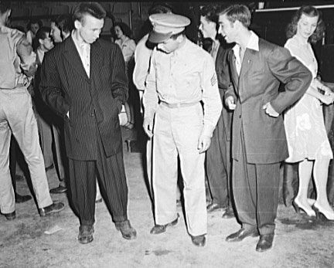

3a. What does the Zoot Suit Riot reveal what was going on in the United States, specifically Los Angeles in 1943? (Hint: Look at the quote “quietly supported by many city and local officials in charge of keeping the peace).

3b. Why did the “Zoot Suit” cause so much conflict during wartime in the United States?

4a-b. The following questions are about these two passages regarding the Atomic Bomb

My division, like most of the ones transferred from Europe was going to take part in the invasion at Honshu (an island of Japan). The people who preferred invasion to A-bombing seemed to have no intention of proceeding to the Japanese front themselves. I have already noted what a few more days would mean to the luckless troops and sailors on the spot.... On Okinawa, only a few weeks before Hiroshima, 123,000 Japanese and Americans killed each other. War is immoral. War is cruel.
-US Soldier Paul Fussell
Russian troops had moved into Hungary and Romania, and Byrnes (advisor to President Truman) thought it would be very difficult to persuade Russia to withdraw her troops from these countries, that Russia might be more manageable if impressed by American military might, and that a demonstration of the bomb might impress Russia. –Leo Szilard, Scientist.
4a. In the first passage does Paul Fussell support or oppose use of the Atomic Bomb. What caused him to come to that conclusion?

4b. In the second passage what is the reason for dropping the atomic bomb? What conflict will this lead into?

Question 5 is about the following 2 passages.

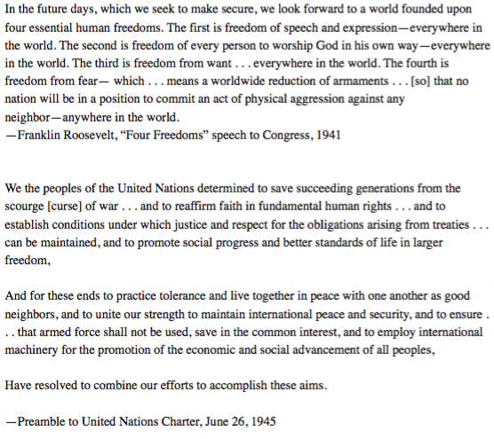

5a. Identify the four freedoms that are listed in his speech to congress in 1941

- Match each of Roosevelt’s Four Freedoms to at least one of the goals stated in the preamble of the United Nations.
Four Freedoms Speech Goals in the United Nations Preable

- Freedom ___________________________________ /
- Freedom___________________________________/
- Freedom___________________________________/
- Freedom___________________________________/

