Questions 1 – 3 refer to the excerpt below

"In the name of God, Amen. We, whose names are underwritten, the Loyal Subjects of our dread Sovereign Lord, King James, by the Grace of God, of England, France and Ireland, King, Defender of the Faith, e&.
Having undertaken for the Glory of God, and Advancement of the Christian Faith, and the Honour of our King and Country, a voyage to plant the first colony in the northern parts of Virginia; do by these presents, solemnly and mutually in the Presence of God and one of another, covenant and combine ourselves together into a civil Body Politick, for our better Ordering and Preservation, and Furtherance of the Ends aforesaid; And by Virtue hereof to enact, constitute, and frame, such just and equal Laws, Ordinances, Acts, Constitutions and Offices, from time to time, as shall be thought most meet and convenient for the General good of the Colony; unto which we promise all due submission and obedience.
In Witness whereof we have hereunto subscribed our names at Cape Cod the eleventh of November, in the Reign of our Sovereign Lord, King James of England, France and Ireland, the eighteenth, and of Scotland the fifty-fourth. Anno Domini, 1620."

- The Mayflower Compact suggests that religious culture among British North American colonists was influenced by:
  - Puritan self-government religious congregation
  - Interest in commerce and business
  - Reliance on agriculture
  - The king and edicts from the British Parliament

- What facts in the article support the argument that the Pilgrims were democratic?
  - It allowed for a civil union between people
  - Everyone got to vote
  - Renewed efforts to stamp out discrimination
  - Supported their royal charter to the mother country

- The Mayflower Compact is important to the concept of a democratic society because it represents
  - an effort by the colonists to use force to resist the King
  - a clear step toward self-government
  - an early attempt to establish universal suffrage
  - an attempt by the colonists to establish freedom of religion

Questions 4 – 6 refer to the excerpt below

“Be it enacted ... That after the five and twentieth day of March, 1698, no goods or merchandizes whatsoever shall be imported into, or exported out of, any colony or plantation to his Majesty, in Asia, Africa, or America ... in any ship or bottom, but what is or shall be of the built of England, Ireland, or the said colonies or plantations ... and navigated with the masters and three fourths of the mariners of the said places only ... under pain of forfeiture of ships and goods.”
— English Parliament, Navigation Act, 1696

- The excerpt most directly reflects which of the following goals for England’s North American colonies?
- Developing them as a producer of manufactured goods
- Aiding them in developing trade with other European nations
- Integrating them into a coherent imperial structure based on mercantilism
- Protecting them from American Indian attacks

- One direct long-term effect of the Navigation Act was that it
  - promoted commercial treaties with Spain and France throughout the 1700s
  - contributed to the rise of opposition that ultimately fostered the independence movement
  - encouraged colonists in North America to expand trade agreements with American Indians
  - led to the imposition of heavy taxes on the North American colonists in the early 1700s

- Under mercantilist doctrine, British currency policies enforced in the colonies were intended to primarily benefit
- backwoods farmers.
- British merchants.
- Virginia tobacco planters.
- the British Crown.

Questions 7– 9 refer to the two excerpts below

To make a Christian out of a Barbarian is not the work of a day. . . . A great step is gained when one has learned to know those with whom he has to deal; has penetrated their thoughts; has adapted himself to their language, their customs, and their manner of living; and when necessary, has been a Barbarian with them, in order to win them over to Jesus Christ.
-French Jesuit Missionary, 1642

Colonies degenerate assuredly when the colonists imitate and embrace the habits, customs, and practices of the natives. There is no better way to remedy this evil than to do away with and destroy completely the habits and practices of the natives.
-Virginia Colony Promoter, William Herbert 1610s

- Which of the following statements characterizes the British relationship with Native Americans?
  - The British viewed Native American culture as a threat to colonization
  - The British believed colonization would only be possible if all Native Americans were destroyed.
  - The British believed that colonization would only be possible if they understood Native American culture.
  - The British modeled their methods of colonization after the example set by the French.

- The French colonizers believed that
  - by assimilating with Native cultures, they could eventually convert them to Christianity.
  - by assimilating with Native cultures, they could improve their own culture.
  - Native Americans should not assimilate with French culture.
  - Christianizing Native Americans was not a realistic goal.

- Based on the passages above, which of the following statements is most accurate?
  - The French did not view Native American culture as a threat to colonization.
  - The British did not view Native American culture as a threat to colonization.
  - Both the French and British were primarily concerned Christianizing Native Americans.
  - Native American culture did not influence the settlement of British and French colonies

Questions 10 – 12 refer to the excerpt below

“Because of their alliance with the Dutch, the Pequots became a thorn in the side of English traders. A series of violent encounters began in July 1636 with the killing of English trader John Oldham and escalated until May 1637, when a combined force of Massachusetts and Connecticut militiamen, accompanied by Narragansett and Mohegan warriors, attacked a Pequot village and massacred some 500 men, women, and children. In the months that followed, the New Englanders drove the surviving Pequots into oblivion and divided their lands…
‘By what right or warrant can we enter into the land of the savages?’ they asked themselves. Responding to such concerns, John Winthrop detected God’s hand in a recent smallpox epidemic ‘If God were not pleased with our inheriting these parts,’ he asked, ‘Why doth He still make room for us by diminishing them as we increase?’ ”
-America’s History, 8th edition - Hendretta, Hinderaker, Edwards and Self. 2014

- What conclusion best supports the authors’ views on the relationships between the Pequot and the Puritans?
  - The English Puritans had relatively hostile relationships with the Pequot.
  - The Pequot supplied a ready source of labor for the Puritans.
  - The English Puritans had relatively hostile relationships with the Narragansett and Mohegan.
  - The English Puritans had relatively cordial relationships with all Native American Indians.

- How did New Englanders’ religious ideas influence their relations with neighboring Native American peoples?
  - Their religious values were used as justification for their actions.
  - Their economic interests were used as justification for their actions.
  - Their religious beliefs placed all humans (including Natives) on an equal level.
  - They approached Native Americans with Evangelical purposes.

- Which of the following is most representative of the authors’ points of view concerning the relations between English settlers and Native Americans?
  - Relations between colonists and Indians in New England were bewilderingly complex.
  - All Native Americans experienced hostile relations with English settlers.
  - All Native Americans experienced friendly relations with English settlers.
  - English settlers had mostly friendly relations with Indians who traded with the Dutch.

Questions 13 - 15 refer to the image below
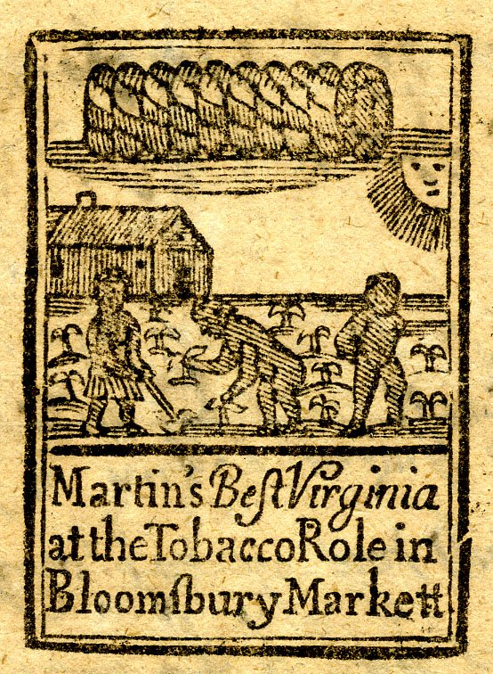

English: "Martin's Best Virginia at the Tobacco Role in Bloomsbury Market," woodcut, advertisement for Virginia tobacco, and showing black children working on a tobacco plantation in Virginia.. Courtesy of the British Museum, London.

- Which aspect of the “Chesapeake economy” is shown in this drawing/woodcut?
- a labor-intensive product that is cultivated by slave labor
- a commerce based economy supported by a merchant class
- the cultivation of staple crops grown by slaves
- the growth of cereal crops/grains

- How did the activities shown in the woodcut lead to increased tensions between the Chesapeake colonists and the native peoples?
  - the colonists expanded their land-holdings in order to plant more tobacco
  - African slaves were brought to the Chesapeake and took jobs from the native people
  - the native peoples felt that tobacco was addictive and dangerous for their health
  - the colonists were making money without giving credit to the native people

- Indians found that British settlers, especially those in the southern colonies, eagerly purchased or captured Indians to use as forced labor in cultivating tobacco, rice, and indigo. Consequently,
  - more and more, Indians began selling war captives to whites rather than integrating them into their own societies.
  - European colonists maintained American Indian slavery to create a harmonious relationship
  - African slaves protest for equal treatment and developed hostile relations with the American Indians
  - the introduction of new crops and livestock by the Spanish had far-reaching effects on native settlement patterns

Questions 16 – 18 refer to the excerpt below

Objection 5: But what warrant have we to take that land, which is and has been of long time possessed of others, the sons of Adam?
“Answer: That which is common to all is proper to none. This savage people rule over many lands without title or property; for they enclose no ground, neither have they cattle to maintain it, but remove their dwellings as they have occasion, or as they can prevail against their neighbors. And why may not Christians have liberty to go and dwell amongst them in their waste lands and woods….Secondly, there is more than enough for them and us. Thirdly, God has consumed the natives with a miraculous plague, whereby the greater part of the country is left void of inhabitants. Fourthly, we shall come in with good leave of the natives.”

John Winthrop, General Considerations for the Plantation in New England with an Answer to Several Objections…, 1629

- Which European approach to colonization is most consistent with the arguments in the excerpt above?
  - Using trade alliances and intermarriage with American Indians to acquire products for export to Europe
  - Establishing tight control over the colonization process to convert and/or exploit the native populations
  - Sending men and women to acquire land and populate settlements while having relatively hostile relationships with the native inhabitants
  - Integrating a coherent hierarchal imperial structure and pursing economic aims

- The author of the excerpt above was most interested in
  - participating in the fur trade with the native communities
  - generating great wealth for the king in England
  - converting American Indians to Christianity
  - justifying the takeover of American Indian lands

- What was the impact of the “miraculous plague” mentioned in the excerpt above?
  - It stimulated cultural and demographic change
  - It led to European accommodation with some aspects of American Indian culture
  - It increased British colonists’ acceptance of intermarriage with native peoples
  - It collapsed the fur trade and lessened access to trade goods

Questions 19 – 21 refer to the following map

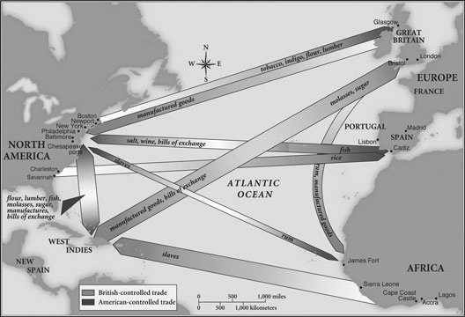

Map of British- and American-controlled trade, 1750
Henretta et al., America’s History, Seventh Edition, Bedford/St. Martin's, p. 95.

- Which of the following best describes the role of Britain’s more northern colonies in the global trade as illustrated in the map above?
  - They took advantage of long growing seasons by using slave labor to grow staple crops
  - They relied solely on the cultivation of tobacco
  - They had an export economy based on food products and raw materials.
  - They primarily exported furs and manufactured goods

- In the 17th and early 18th centuries, Britain’s greatest challenge in controlling the North American Atlantic trade illustrated above was
  - the growth of regional distinctiveness
  - external competition
  - repeated colonial wars.
  - widespread corruption in the imperial system

- Which of the following is a 16th century idea that reflects the trade patterns in the map above?
  - encomienda system
  - spread of maize cultivation
  - Columbian Exchange
  - Spanish Mission system

Questions 22 - 23 refer to the following picture

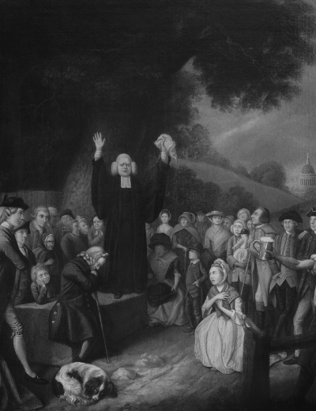

John Collet, George Whitefield Preaching¸18th Century
Private Collection / The Bridgeman Art Library

- Which colonial trend from the 17th and 18th centuries is best illustrated by the image above?
  - The spread of Enlightenment thought
  - The Anglicanization of the British colonies
  - Puritans seeking to establish a community of religious believers
  - The Great Awakening

- By the mid-18th century, the fervor illustrated in the image above
  - contributed to resistance toward imperial control.
  - stimulated the growth of ideas on race, leading to racial stereotyping.
  - led to the growth of autonomous political communities based on English models.
  - supported accommodation with some aspects of American Indian culture.

Questions 24 – 26 refer to the excerpt below

“…Whereas the enforcing of the conscience in matters of religion has frequently fallen out to be of dangerous consequence in those commonwealths where it has been practiced, and for the more quiet and peaceable government of this Province, and the better to preserve mutual love and amity among the inhabitants thereof. Be it therefore enacted that no person or persons whatever in the Province…professing to believe in Jesus Christ, shall from henceforth be any ways troubled, molested, or discountenanced for or in respect of his or her religion nor in the free exercise thereof within the Province…nor in any way compelled to the belief or exercise of any other religion against his or her consent, so [long] as they not be unfaithful to the Lord Proprietary, or molest or conspire against the civil government established in this Province under him…”
The General Assembly of Maryland, meeting in St. Mary’s City, adopted The Act of Toleration (formally “An Act Concerning Religion”) on April 21, 1649.

- The passage above was most likely written in response to
  - the growth of autonomous political communities based on English models.
  - Protestant evangelism in North America.
  - the ethnic and religious diversity of the middle colonies.
  - the expanding social networks of the Atlantic World.

- The ideas expressed in the passage above most clearly show the influence of which of the following?
  - Resistance to imperial control in the British colonies
  - The British government’s indifference to colonial governance
  - Greater religious independence in the colonies
  - A strong belief in British cultural superiority

- The ideas expressed in the passage above most directly led to political controversies over
  - Britain’s indifference to colonial governance.
  - Britain’s efforts to pursue mercantilist economic aims.
  - the presence of slavery in the colonies.
  - the spread of European Enlightenment ideas.

Questions 27 - 29 refer to the excerpt below.

“The colonizers brought along plants and animals new to the Americas, some by design and others by accident. Determined to farm in a European manner, the colonists introduced their domesticated livestock—honeybees, pigs, horses, mules, sheep, and cattle—and their domesticated plants, including wheat, barley, rye, oats, grasses, and grapevines. But the colonists also inadvertently carried pathogens, weeds, and rats....In sum, the remaking of the Americas was a team effort by a set of interdependent species led and partially managed (but never fully controlled) by European people.”
Alan Taylor, historian, American Colonies, 2001

- The export of New World crops to the Old World transformed European society mostly by
  - improving diets and thereby stimulating population growth
  - encouraging enclosure of open lands and pushing workers off of farms
  - promoting greater exploration of the interior of the American continents
  - fostering conflicts among major powers over access to new food supplies

- The patterns described in the excerpt most directly foreshadowed which of the following developments?
  - The spread of maize cultivation northward from present-day Mexico into the American Southwest
  - The population decline in Native American societies
  - The gradual shift of European economies from feudalism to capitalism
  - The emergence of racially mixed populations in the Americas

- The trends described by Taylor most directly illustrate which of the following major historical developments in the Atlantic world?
  - The growth of mercantile empires that stretched across the Atlantic
  - The increasing anglicization of the English colonies
  - The phenomenon known as the Columbian Exchange
  - The rise of the trans-Atlantic slave trade

Questions 30 - 32 refer to the excerpt below
For the Puritans, to "redeem the time" (as Baxter put it) meant to order one's daily life in accordance with godly principles and for maximum effectiveness. One of the Puritans' favorite epithets was well-ordered. Their opponents nicknamed them the disciplinarians. The Puritans aspired to be worldly saints—Christians with earth as their sphere of activity and with heaven as their ultimate hope. Baxter exhorted his readers, "Write upon the doors of thy shop and chamber, … This is the time on which my endless life dependeth." This approach to life resulted in three vintage Puritan traits: the ideal of the God-centered life, the doctrine of calling or vocation, and the conviction that all of life is God's.
Leland Ryken The Original Puritan Work Ethic, 2006

- The trends described by Ryken most directly illustrate which of the following major historical developments in the colonies
  - Their sense of priority of a God-centered life would establish a close knit homogeneous society
  - The emergence of racially mixed populations in the Americas
  - Encouraging enclosure of open land and pushing Natives off their lands
  - Economic hardship in Europe as more people emigrated to the puritan colonies

- The Puritans who settled New England hoped to:
  - create a model religious society based on biblical principles
  - establish good trade relations with the French in Canada
  - get rich quick by finding gold and silver
  - separate church and state to safeguard religious freedom

- Which of the following most accurately describes the attitude of seventeenth-century Puritans toward religious liberty?
  - They tolerated no one whose expressed religious views varied from their own views.
  - They tolerated all Protestant sects, but not Catholics.
  - They tolerated Catholics, but not Quakers.
  - They had no coherent views on religious liberty.

Questions 33 – 35 refer to the map below

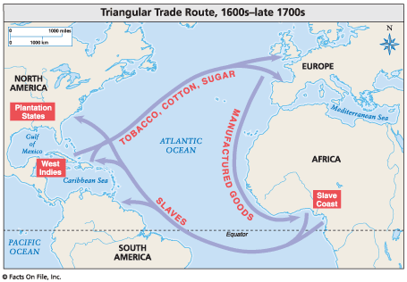
- How did the rise of the triangle trade system impact the economic development in the colonies?
  - American port cities grew in size and complexity
  - It increased the need for slaves in the New England colonies
  - It created an industrial capital in the southern colonies
  - Decreased the power of the British mercantilist system
- How would the system shown in the image above encourage the break from England in the late 1700s?
  - It encouraged the gradual shift from dependence on the mother country to capitalism
  - The increasing Anglicization of the English colonies
  - Promoted greater exploration of the interior of the American colonies
  - Atlantic slave trade rapidly decreased in the early 18th century
- Which economic system was responsible for the creation of the situation on the map?
  - Mercantilism
  - Feudal
  - Socialism
  - Barter

