DESCRIBE! SUPPORT! EXPLAIN!

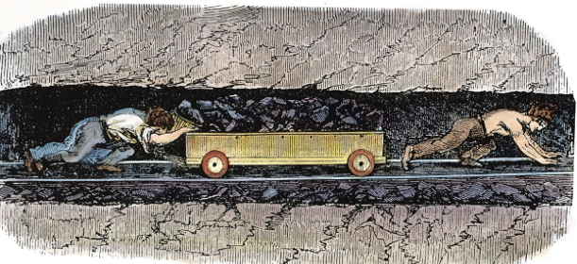

Describe: For 3 Documents, you must describe the content of the document.
- Example: A painting showing child labor in an English Coal Mine.

Support: For 6 Documents, you must use the document to support your argument.
- Example: A painting showing child labor in an English Coal Mine, showed the brutal working conditions the working class went through.

Explain: You must use a HIPP sentence for 3 of the documents.
- A painting showing child labor in an English Coal Mine showed the brutal working conditions the working class went through…..
- Historical Context: At the time, Laissez-Faire economics allowed horrible working conditions.
- Intended Audience: This painting directed at the people led to changes in working conditions.
- Purpose: The purpose is to get those outside of the factories to understand the working conditions.
- Point of View: The artist believes that children are being exploited.

